**LIFE CYCLE COSTS OF BRIDGES:**

**GALVANIZED STEEL vs. CONCRETE**

**Prepared For**

**US BRIDGE**

**Cambridge, Ohio**

**Michael G. Barker, PhD, PE Professor**

**Civil & Architectural Engineering University of Wyoming**

**January 1, 2018**

**© 2018 Michael Barker & U.S. Bridge**

***Copies with this notice permitted***

# Background and Conclusions

In 2016, the author published a study titled, *Historical Life Cycle Costs of Steel & Concrete Girder Bridges* ([www.ShortSpanSteelBridges.org](http://www.shortspansteelbridges.org/)). The primary conclusion from that study was that, notwithstanding the prevailing assumption that concrete bridges are more economical than steel bridges, for typical bridges (steel rolled beam, steel plate girder, concrete box adjacent, concrete box spread and concrete I beam bridges), all were economically competitive. The Executive Summary from the original Life Cycle Costs report is in the Appendix of this report.

However, none of the bridges in the study’s database used galvanized beams or girders. Hot Dip Galvanizing with Zinc (HDG) is an old science but its application to bridges is relatively recent. US Bridge of Cambridge, OH, which serves secondary highway systems throughout the country and is the sponsor of this study, claims to have been the first to hot dip galvanize entire welded truss bridge sections in 1987. Since then, the federal government has recommended HDG for bridge designs intended to last a century[1], a relatively new expectation considering that only a few decades ago the objective was a service life of 50 years. One reason for this is the increasingly limited funds for local bridge construction and repair. As a result, many counties in the United States now routinely specify galvanized bridges for their longer term economy.[2] However, until now, no one has produced a study of the measurable financial benefits of HDG. This report attempts to fill that void.

:

This study has been based on certain assumptions: (1) all painted bridges used in the original study were HDG instead of painted; (2) the cost of HDG and modern multi-coat painting systems are roughly the same; and (3) HDG eliminates corrosion and most steel maintenance, thereby extending average service life by at least 25 years. The latter two assumptions reasonably approximate industry experience when using galvanized members.

The general conclusions are that, by the use of HDG for typical steel bridges such as those in the previous study, the present value cost of future maintenance is reduced 50%, Capitalized Costs are reduced 8.5%; and galvanized steel bridges can have Capitalized Costs less than the best concrete alternatives.

Table of Contents

Background and Conclusions i

List of Tables iv

List of Figures iv

Bridge Database 1

Life Cycle Cost Analysis and Capitalized Cost 2

Initial Cost and Future Maintenance 2

End-of-Life Model 2

2014 Built Date and Inflated Costs 3

Discount Rate 3

Review of Life Cycle Cost Results (Original Study with No Galvanizing) 4

Bridge Life 4

Perpetual Present Value Costs / Capitalized Costs – All Bridges 5

Perpetual Present Value Costs / Capitalized Costs – Short Length Bridges (L ≤ 140 ft) 6

Effects of Galvanizing 6

Galvanizing as a Steel Protection System 6

Life Cycle Costs for Galvanized Steel Bridges 8

Example Life Cycle Cost Study for Galvanization 8

Database Results for Galvanization 11

Life Cycle Cost Results Due to Galvanizing: 13

Summary and Conclusions 14

Appendix – Executive Summary from *Historical Life Cycle Costs of Steel & Concrete Girder Bridges*, Barker, 2016, www.ShortSpanSteelBridges.org 15

**EXECUTIVE SUMMARY**

**LIFE CYCLE COSTS OF BRIDGES:**

**GALVANIZED STEEL vs. CONCRETE**

Page:

* Number of bridges in study: 198 steel, 988 concrete 1
* Actual records of PennDOT were used for calculations 2
* Average bridge life for each type are from 74 to 81 years 4
* Galvanizing adds 25 years to steel bridge life 7
* First galvanized bridge in US is maintenance free for 97 years 7
* Galvanizing eliminates future painting costs 7
* Galvanizing eliminates future steel repair costs 8
* Without maintenance painting, life of a steel bridge was 36 years 8
* With galvanizing, life of a steel bridge would have been 108 years 10
* With galvanizing, capitalized cost would have been reduced 19.5% 10
* Galvanized steel bridges have 97 - 99% probability of 75 - year life 11
* Concrete bridges have 44-66% probability of 75 - year life 11
* All steel bridges have $265/sq. ft. life cycle cost 12
* All galvanized steel bridges have $242/sq. ft. life cycle cost 12
* All concrete bridges have $217- $278/sq. ft. life cycle cost 12
* Max. lgth. 140 ft. steel bridges $277-$313/sq. ft. life cycle cost 12
* Max. lgth. 140 ft. galv. steel bridges $254-$285/sq. ft. life cycle cost 12
* Max. lgth. 140 ft. concrete bridges $281-$292/sq. ft life cycle cost 12
* All galv. steel bridges future maintenance cost reduced 50% 13
* All galv. steel bridges capitalized cost reduced 8.5% 13
* All steel bridges 5.3% more cap. cost than concrete 13
* All galv. steel bridges 3.2% less cap. cost than concrete 13
* Max. lgth. 140 ft. all steel bridges 1.9% more cap. cost than concrete 13
* Max. lgth. 140 ft. all galv. steel bridges 6.5% less cap. cost than concrete 13

# List of Tables

Table 1: Final Life Cycle Cost Database 1

Table 2: Average Deterioration Rates 3

Table 3: Bridge Life 4

Table 4: Life Cycle Cost Results Using Total Database 5

Table 5: Life Cycle Cost Results for Bridge Length Maximum = 140 ft 6

Table 6: Painted Bridges 8

Table 7: Repaired Steel Bridges 8

Table 8: Life Cycle Costs for All Bridges 12

Table 9: Life Cycle Costs for Bridge Length Maximum = 140 ft 12

Table 10: Life Cycle Costs for All Steel Bridges 12

# List of Figures

Figure 1: Probability Density Function for Bridge Life 4

Figure 2: Probability Density Function for Capitalized Cost 5

Figure 3: Time to First Maintenance for Hot Dip Galvanized Bridges2 7

Figure 4: PennDOT Bridge 6520 Life Cycle Cost Timeline 9

Figure 5: PennDOT Galvanized Bridge 6520 Life Cycle Cost Timeline 10

Figure 6: Probability Density Function for Galvanized Bridge Bridge Life 11

Figure 7: Probability Density Function for Galvanized Capitalized Cost 12

## Bridge Database

For each bridge in the database, the Life Cycle Cost analysis required: the year built and the initial cost, dates and costs for repairs, maintenance and rehabilitations, and the reasons for the work. The bridges in the study were simple- and multi-span “regular type” rolled steel (Steel I Beam), plate girder (Steel I Girder), precast adjacent box beam (P/S Box - Adjacent), precast spread box beam (P/S Box - Spread), and precast I-beam (P/S I Beam) bridges. The years of inclusion were set to bridges built between 1960 (modern era for prestressed concrete and steel construction techniques) and 2010. The bridge database used for the Life Cycle Cost analyses includes a subset of the total Pennsylvania DOT bridge inventory due to missing data for individual bridges. The final Life Cycle Cost bridge database consists of 1186 state bridges out of a potential of 6587 built between 1960 and 2010. This means the database represents 18% of the inventory. None of the steel bridges in the database were galvanized, although several were built with weathering steel superstructures.

The following describes the criteria applied for inclusion in the final LCC bridge database:

Modern typical bridge structures

Steel Rolled Shape and Welded Plate Girder bridges

Concrete Box Adjacent, Box Spread and Precast I-Beam bridges

Bridges built between 1960 and 2010

Bridges with complete and accurate department maintenance records

Known dates and Known costs

Consider any maintenance cost that is equal to or greater than $0.25/ft2

Bridges with known initial costs

Bridges with complete and accurate external contractor maintenance and rehabilitation records, known dates and Known costs

Initial cost limitation to bridges with initial cost less than $500/ft2 and greater than $100/ft2

Since the objective was to study typical bridges, additional bridges were removed from the database using statistical criteria based on standard deviations. Table 1 shows the total number of each type of bridge in the bridge database.

###### Table 1: Final Life Cycle Cost Database

|  |  |  |  |
| --- | --- | --- | --- |
| **Bridge Type** | **Bridges in LCC Study Database** | **Potential Number of Bridges** | **Percent of**  **Potential** |
| Steel I Beam | 54 | 550 | 9.8% |
| Steel I Girder | 144 | 1017 | 14.2% |
| P/S Box - Adjacent | 282 | 1440 | 19.6% |
| P/S Box - Spread | 397 | 2196 | 18.1% |
| P/S I Beam | 309 | 1384 | 22.3% |
| Total | 1186 | 6587 | 18.0% |

## Life Cycle Cost Analysis and Capitalized Cost

Life Cycle Cost analysis represents the “total” cost of a bridge over the life of the bridge and results in an equivalent Life Cycle Cost. The cost amount is typically represented by either an Equivalent Uniform Annual Cost (EUAC) or a Present Value Cost (PVC). The EUAC is the life cycle cost amount annualized over the life of the bridge. The PVC represents a present amount that, at a given discount rate, will be enough to pay the initial cost of the bridge and all future costs that are associated with the bridge over its life. However, when comparing bridges that have different bridge lives, a Present Value Cost by itself is not sufficient. For instance, if a bridge lasts 80 years with a certain PVC, it cannot be directly compared to the Present Value Cost of a bridge that lasts only 60 years. Therefore, common methods to directly compare bridges with different life spans is to use either Equivalent Uniform Annual Costs (EUAC) or a Perpetual Present Value Cost (PPVC), also called a Capitalized Cost (CC), where it is assumed the bridge is replaced by an identical bridge at the end of each life cycle. Both are equivalent in terms of use for cost comparisons. The PPVC or CC method is used in this work. An example of Life Cycle Costs analysis is shown under the Effect of Galvanizing section of this report.

The data required for a Life Cycle Cost analysis are the initial cost and any future maintenance costs and their time frames associated with the bridge over the life of the bridge, an end-of-life model for each bridge, a method to inflate costs to a constant dollar built date (here 2014) for equivalent bridge cost comparisons, and an appropriate discount rate.

### Initial Cost and Future Maintenance

Pennsylvania DOT recorded initial cost and date, and recorded maintenance and dates, were used to develop the historical life cycle for each bridge. Superstructure only maintenance, including concrete deck work, was considered where the costs may be from DOT departmental or external contracted work. Maintenance costs exceeding $0.25/ft2 of deck area were included in the Life Cycle Costs.

### End-of-Life Model

In the Life Cycle Cost analysis, the end of life of the bridge (when the bridge needs replacement) defines the life cycle of the bridge. Since the bridges in the bridge database are all currently in service, it was necessary to estimate an end of life date for each bridge. This was accomplished through the use of average deterioration rates based on Superstructure Condition Rating deterioration over time. To model the deterioration rate, it was assumed that the condition rating decreased linearly over time and the bridge is assumed to be replaced when the condition rating reached 3. Also it is assumed that the condition rating is 9 when the structure was built. Thus, for a given bridge in the year 2014, the deterioration rate is:

$$Deterioration Rate=\frac{\left(2014 Condition Rating\right)-9}{2014-(Year Built)}$$

All 6587 of the potential bridges built between 1960 and 2010 were used to determine the average deterioration rates for the different types of bridges as shown in Table 2.

###### Table 2: Average Deterioration Rates

|  |  |  |
| --- | --- | --- |
| **Bridge Type** | **Number of Bridges**  **1960 - 2010** | **Deterioration Rate**  **(Condition Rating Loss/Year)** |
| Steel I Beam | 550 | -0.0711 |
| Steel I Girder | 1017 | -0.0814 |
| P/S Box - Adjacent | 1440 | -0.0813 |
| P/S Box - Spread | 2196 | -0.0799 |
| P/S I Beam | 1384 | -0.0838 |

To estimate the remaining life for each bridge, it is assumed that the bridge will be replaced when the superstructure condition rating reaches 3 for the average deterioration rates from Table 9:

$$Remaining Life=\frac{3- \left(2014 Condition Rating\right)}{(Average Deterioration Rate)}$$

The bridge life becomes:

$$Bridge Life=2014-\left(Year Built\right)+Remaining Life$$

and the end of life year, for the Life Cycle Cost analysis, becomes:

$$End of Life Year=2014+Remaining Life$$

### 2014 Built Date and Inflated Costs

For a comparison of the costs over the bridge types, the historical costs must consider inflation over the years. For this study, it was assumed that each bridge in the database was built in the year 2014 for a consistent comparison. The dollars at the time expended are transformed into constant 2014 dollars using Construction Cost Indices (CCI) provided by Engineering News Record publications. Therefore, the historical costs are inflated to an equivalent amount in 2014. The constant 2014 dollars is necessary to (1) account for inflation to transform past built bridges to 2014 using the Construction Cost Index and (2) the discount rate for all future costs considers future inflation and discounting future costs with the discount rate is applied to constant 2014 dollars.

### Discount Rate

For Life Cycle Cost analysis, the discount rate represents the effective interest rate, accounting for inflation, used to discount cash flow (time value of money). The effective discount rate allows time value of money analysis using today’s costs (constant dollars) and removes the need to consider inflation and discounting separately. With inflation, the actual cost in the future will exceed the constant dollar today cost, but the cost today will grow over time at an interest rate (greater than the discount rate) that will be able to pay for the inflated actual cost in the future. The effective discount rate of 2.3% used in this study is taken from the Federal Office of Management and Budget Circular No. A-94, *Guidelines and Discount Rates for Benefit-Cost Analysis of Federal Programs*.

## Review of Life Cycle Cost Results (Original Study with No Galvanizing)

### Bridge Life

An important consideration for bridge owners is bridge life. Table 3 presents the average year built and the average bridge life for the different bridge types in the bridge database. As shown in Table 3, the Steel I Beam bridges have the longest average bridge life. Assuming that the behavior follows a normal distribution, Figure 1 demonstrates the Probability Density Function (PDF) bridge life behavior of the different bridge types. The PDF shows the mean and the standard deviation characteristics.

###### Table 3: Bridge Life

|  |  |  |
| --- | --- | --- |
| **Bridge Type** | **Average Year**  **Built** | **Average Bridge Life**  **(years)** |
| Steel I Beam | 1981 | 81.3 |
| Steel I Girder | 1977 | 79.2 |
| P/S Box - Adjacent | 1985 | 74.0 |
| P/S Box - Spread | 1984 | 79.9 |
| P/S I Beam | 1984 | 74.5 |

A useful way to use such data is to ask the question, what is the probability that the bridge life exceeds 75 years for the different bridge types? Still assuming the probability distribution is normal, the probability that a bridge type has a life exceeding 75 years is also shown on Figure 1. There is a 73% probability (confidence for bridge owners) that a Steel I Beam bridge will have a bridge life that exceeds 75 years, but only a 44% probability for a P/S I Beam bridge. The probabilities are between these two for the other types of bridges.

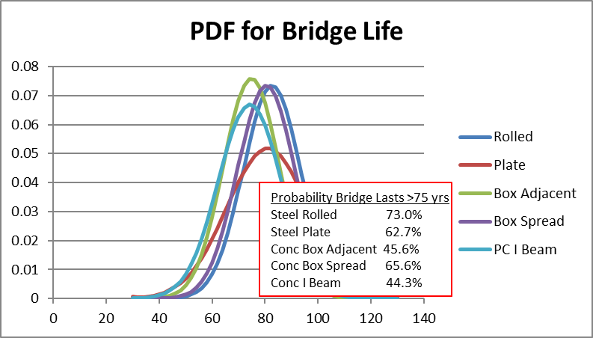

##### Figure 1: Probability Density Function for Bridge Life

In the section on the Effects of Galvanizing, it will be demonstrated that Life Cycle Costs decrease as galvanizing extends the life expectancy for steel bridges.

### Perpetual Present Value Costs / Capitalized Costs – All Bridges

Table 4 presents the results of the Life Cycle Cost study for the averages over the entire database. The Capitalized Cost (PPVC/CC), in $/ft2 of deck area, is the quantity that can be used to equally compare over different bridge types. The least expensive alternative is the P/S I Beam ($217.50/ft2), followed by the Steel I Beam ($232.78/ft2). Also shown in Table 4 are the average Initial Costs and the present value of future maintenance costs, along with the average bridge length, number of spans, year built and bridge life.

###### Table 4: Life Cycle Cost Results Using Total Database



As with bridge life, assuming that the behavior follows a Normal distribution, Figure 2 demonstrates the Probability Density Function (PDF) for the Capitalized Costs behavior of the different bridge types. The PDF shows the mean and the standard deviation characteristics. Again, a useful way to use such data is to ask the question, what is the probability that the Capitalized Cost is less than $300/ft2 for the different bridge types? As also shown in Figure 2, there is a 93% probability (confidence for bridge owners) that a P/S I Beam bridge, and an 88% probability that a Steel I Beam bridge, will have a Capitalized Cost less than $300/ft2. The probabilities decrease for the other types of bridges.

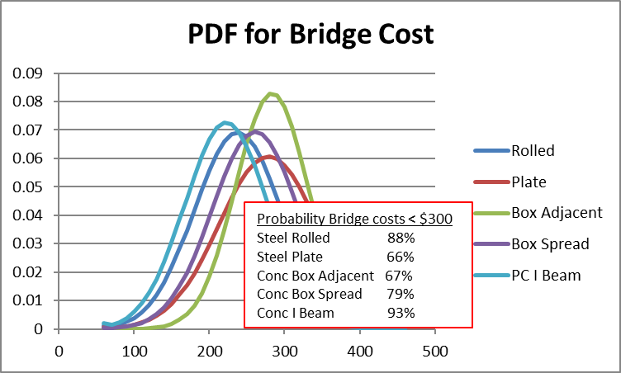

##### Figure 2: Probability Density Function for Capitalized Cost

In the section on the Effects of Galvanizing, it will be demonstrated that Life Cycle Costs decrease as galvanizing extends the life expectancy for steel bridges and decreases future maintenance of steel bridges.

### Perpetual Present Value Costs / Capitalized Costs – Short Length Bridges (L ≤ 140 ft)

The costs shown in Table 4 represent the averages for all of the bridges in the database. However, there is significant variation in average bridge length and number of spans. Therefore, this section examines bridges with lengths less than or equal to 140 ft. The bridge industry considers this length as the definition of short span bridges. And, a great majority of bridges in the United States are considered short span, thus, the results represent the majority of the bridges in the US and the results can be compared on a more consistent basis.

Table 5 presents the results for bridges that have a maximum span of 140 ft. Here the Steel I Beam bridges have the least Capitalized Cost with Precast Box Beam – Spread next. All of the average Capitalized Costs are greater than those of the entire database due to the nature of building shorter bridges, yet with the same substructure requirements.

###### Table 5: Life Cycle Cost Results for Bridge Length Maximum = 140 ft



Since short length bridges are the great majority of bridges in service, the section on the Effects of Galvanizing will demonstrate that Life Cycle Costs decrease for short length bridges as galvanizing extends the life expectancy for, and decreases future maintenance of, steel bridges.

## Effects of Galvanizing

### Galvanizing as a Steel Protection System

Steel protection systems typically consist of painting the steel, using weathering grade steel, or galvanizing the steel. There were no galvanized bridges that made it into the existing bridge database. This is unfortunate because protective coating systems is an important aspect of steel bridges and galvanizing has become an economical and effective protection system. Recent information shows that Hot Dipped Galvanizing initial costs are approximately equal to or even less than a quality three-coat paint system. Paint systems also need maintenance over the bridge life, whereas galvanizing usually does not, or it may require a minor zinc-rich spot painting at about 60 years. With the superior protection of galvanizing, there would be little or no steel deterioration over the life of the bridge and, thus, galvanizing also significantly increases the life of a steel bridge.

The extended life applied to the steel bridges in this study assumes that Hot Dip Galvanizing will add 25 years to the life of each bridge in the database. Figure 3 is the predicted Time-to-First-Maintenance for galvanized bridge beams and girderspublished by the American Galvanizers Association.[3] The chart shows that, for the minimum required zinc coating for bridges of 3.9 mils, the time before at most 5% of the zinc coating is exhausted is 95 years for suburban bridges and well over 100 years for rural bridges. The bridge would still have service life significantly past the 95th year for even suburban bridges when only part of the galvanizing is exhausted. Thus, it seems a reasonable approximation to assume a 105 year life if the bridges were galvanized. Since the average life of the steel bridges in the original Life Cycle Cost study was approximately 80 years, galvanizing would add a life extension of 25 years.



##### Figure 3: Time to First Maintenance for Hot Dip Galvanized Bridges2

A historic example to support the 25 year extended life is the Stearns Bayou Bridge in Robinson Township, MI.[4] The bridge, built in 1966 over a water crossing and subject to winter road salting, is believed to be the first galvanized bridge in the United States. In a 1997 inspection, the steel superstructure was in very good shape with good zinc thicknesses, and it was estimated that the bridge had an additional 66 years to Time of First Maintenance. This predicts a 97 year maintenance free life that would certainly result in a service life exceeding 105 years.

Table 6 lists the number of paint maintenance events for the steel bridges in the database. The present value of the average future painting costs for the rolled beam and plate girder bridges are $1.44/ft2 and $0.21/ft2, respectively. If galvanizing was an option, these future costs would be eliminated.

###### Table 6: Painted Bridges



Table 7 lists the rolled beam and plate girder maintenance events that include repairing or replacing steel members, cross diaphragms, and end bearing seats. The present value of these average future maintenance costs for the rolled beam and plate girder bridges are $9.87/ft2 and $1.08/ft2, respectively. If the bridge was galvanized, the deterioration that caused these maintenance events would be eliminated.

###### Table 7: Repaired Steel Bridges



### Life Cycle Costs for Galvanized Steel Bridges

The objective of this study was to develop useful owner information on the effects of galvanizing on the historical Life Cycle Costs for typical bridges. The non-weathering steel bridges in the current database are modified by assuming the steel had been galvanized instead of painted when built. Several assumptions are applied to modify the steel bridge life cycle due to the galvanization:

1. Galvanization adds 25 years to the each bridge life due to superior steel protection;
2. Galvanizing costs are the same as a quality paint system, therefore bridge initial costs do not change;
3. Painting costs are removed from the maintenance record; and
4. Repairs to the beams and girders are removed from the maintenance record.

Concrete deck and deck joint repairs remain in the maintenance record since it is assumed galvanizing the beams and girders does not impact the deck performance.

### Example Life Cycle Cost Study for Galvanization

To demonstrate the Life Cycle Cost analyses for galvanization, a simple example with limited inputs is used here. PennDOT Bridge 6520 from the database is an extreme example where there was no maintenance painting, thus severe deterioration caused replacement of the steel girders after 36 years.

BrKey: 6520

Bridge Type: Steel Rolled Beam

County: Bradford

Location: 1 mi West of Sayre Boro

Year Built: 1973

Spans: 3

Length: 220 ft

Deck Area: 10560 ft2

Super Cond Rating: 6

Using the average Steel I Beam bridge deterioration rate of -0.0711 from Table 2, with a superstructure condition rating of 6, the remaining life is:

$$Remaining Life=\frac{(3-6)}{-0.0711}=42 years$$

The bridge life is estimated to be:

$$Bridge Life=2014+42-1973=83 years$$

There was only one incident of maintenance - to replace the steel girders. For this example, total costs and costs/ft2 of deck area are shown. The remainder of this report will use costs/ft2 for direct comparisons. The costs at the time of the work and year of the work are:

Initial Cost: Year = 1973 Cost = $247,770 ($23.46/ft2) Work: Bridge Construction

Maintenance: Year = 2009 Cost = $390,000 ($36.93/ft2) Work: Replace Steel Girders

To transform the costs to constant 2014 dollars, Construction Cost Indices are applied by multiplying the cost in Year XXXX by (CCI2014/CCIXXXX). To set the time frame for the Life Cycle Cost analysis, the date of maintenance from the built date of Year 0 is determined. The inputs for the LCC analysis are:

Initial Cost: Year = 0 Cost = $23.46/ft2(9806/1895) = $121.41/ft2

Maintenance: Year = 36 Cost = $36.93/ft2(9806/8570) = $ 42.26/ft2

The bridge life timeline is shown in Figure 4.

0 30 60 83 years

Replace with Identical Bridge

Every 70 years

Initial Cost

$143.45/ft2

Maintenance

$0.28/ft2

##### Figure 4: PennDOT Bridge 6520 Life Cycle Cost Timeline

To determine the Present Value Cost, the future cost is discounted to year 0 with a discount rate of 2.3% and added to the initial cost:

$$PVC=\$121.41+\$42.26{(1.023)}^{-36}=\$140.05/{ft}^{2}$$

The Present Value Cost of only the future costs (maintenance and contracts) is:

$$Maintenance PVC=42.26{\left(1.023\right)}^{-36}= \$18.64/{ft}^{2}$$

Finally, to compare this bridge with others in the database, the Perpetual Present Value Cost, the Capitalized Cost, for Bridge 6520 is:

$$PPVC=\$140.05\left[\frac{{\left(1+0.023\right)}^{83}}{{\left(1+0.023\right)}^{83}-1}\right]=1.179\left(\$140.05\right)=\$165.05/{ft}^{2}$$

If this bridge is assumed to be galvanized, the maintenance cost for repairing the steel girders no longer applies. Also, the bridge life is extended to 83 + 25 = 108 years due to the galvanizing. Figure 5 shows the Galvanized Bridge 6520 life cycle.

0 30 60 90 108 years

Replace with Identical Bridge

Every 70 years

Initial Cost

$143.45/ft2

##### Figure 5: PennDOT Galvanized Bridge 6520 Life Cycle Cost Timeline

The Present Value Cost is equal to the initial cost with no maintenance:

$$PVC=\$121.41/{ft}^{2}$$

The Present Value Cost of maintenance is:

$$Maintenance PVC=\$0.00/{ft}^{2}$$

Finally, to compare this bridge with others in the database, the Perpetual Present Value Cost, the Capitalized Cost, for Galvanized Bridge 6520 is:

$$PPVC=\$121.41\left[\frac{{\left(1+0.023\right)}^{108}}{{\left(1+0.023\right)}^{108}-1}\right]=1.094\left(\$121.41\right)=\$132.81/{ft}^{2}$$

Using the assumptions for galvanizing, for this particular and rather extreme case, the present value of future maintenance is reduced 100% (no future maintenance with galvanizing).

The Capitalized Costs are reduced 19.5%% (1 – 132.81/165.05). If this bridge is assumed to be galvanized, Capitalized Costs are reduced and the bridge lasts longer.

Applying the galvanizing to the steel bridges in the bridge database, except for the Weathering Steel bridges, will not be this extreme with high costs associated with girder replacement, and there will be future costs considered for deck maintenance.

### Database Results for Galvanization

The galvanizing was applied to the rolled beam and plate girder bridges in the database, except the weathering steel bridges (15 rolled beam and 11 plate girder) were removed. The galvanized bridge results are compared to the original non-weathering steel database assuming no galvanizing and with the concrete bridge alternatives. A bridge life comparison in Figure 6, similar to Figure 1, shows that the galvanized Steel I Beam bridges and the Steel I Girder bridges, with an additional 25 years of life, have a 99.8% and 97.4% probability of lasting over 75 years, respectively, compared to the concrete bridge types of between 44% and 66% probability.

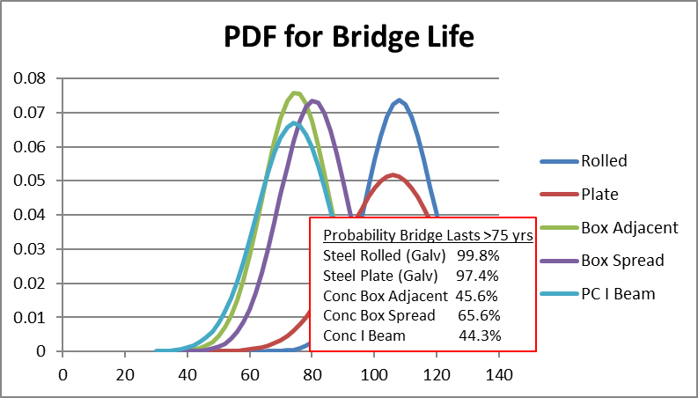

##### 

##### Figure 6: Probability Density Function for Galvanized Bridge Bridge Life

There is a significant impact on the Capitalized Costs due to galvanizing. Table 8 shows the results for all non-weathering steel bridges, the galvanized bridges, and the concrete alternatives. Due to galvanizing, Figure 7, like Figure 2 for Capitalized Costs, shows that there is a 94% probability that a Steel I Beam bridge has Capitalized Costs less than $300/ft2, compared to the 93% probability for the P/S I Beam bridge, a reversal of “best alternative” from the non-galvanized analysis shown in Figure 2. Table 9 are the results for bridges with a maximum length of 140 ft as was examined previously since short span bridges are prevalent. Table 10 combines the results for the rolled beam and plate girder bridges into one category for all the non-weathering bridges in the database.

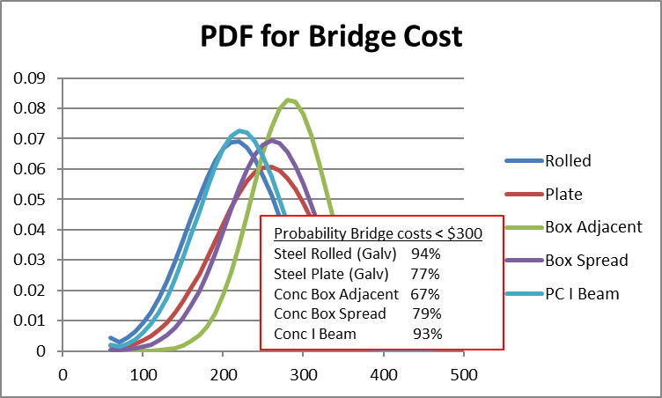

##### Figure 7: Probability Density Function for Galvanized Capitalized Cost

###### Table 8: Life Cycle Costs for All Bridges



###### Table 9: Life Cycle Costs for Bridge Length Maximum = 140 ft



###### Table 10: Life Cycle Costs for All Steel Bridges



The galvanized bridges have significantly lower Capitalized Costs and last 25 years longer compared to the non-weathering steel bridges. The reduced Capitalized Costs also result in steel bridges being more competitive compared to concrete alternatives.

### Life Cycle Cost Results Due to Galvanizing:

**(Table 10)** For All Steel Bridges, Present Value of Future Maintenance Costs Reduced 50% (1-0.15/0.30)

**(Table 8)** Rolled 95% Reduction (1-0.03/0.56)

**(Table 8)** Plate 22% Reduction (1-0.18/0.23)

**(Table 10)** For All Steel Bridges, Capitalized Costs Reduced 8.5% (1-242.31/264.82)

**(Table 8)** Rolled 8.1% Reduction (1-210.49/228.95)

**(Table 8)** Plate 8.6% Reduction (1-251.64/275.34)

**(Table 9)** For Bridges with Max Length = 140 ft, Capitalized Costs

**(Table 8)** Rolled 8.2% Reduction (1-254.46/277.34)

**(Table 8)** Plate 9.0% Reduction (1-285.22/313.42)

**(Table 8)** For All Steel Bridges, Galvanized Steel I Beam Less Expensive than Best Concrete by 3.2% (1-210.49/217.50) vs. Steel I Beam More Expensive by 5.3% (228.95/217.50-1) for Non-Galvanized

**(Table 9)** For Max L = 140 ft Bridges, Galvanized Steel I Beam Less Expensive than Best Concrete by 6.5% (1-254.46/272.20) vs. Steel I Beam More Expensive by 1.9% (277.34/272.20-1) for Non-Galvanized

## Summary and Conclusions

The objective of this study was to develop useful owner information on the effects of galvanizing on the historical Life Cycle Costs for typical steel bridges. Life Cycle Cost analyses for galvanized steel bridges was applied to an existing database of bridges from Pennsylvania that was used for a Historical Life Cycle Cost analysis of typical steel and concrete bridges (Barker, 2016, *Historical Life Cycle Costs of Steel & Concrete Girder Bridges*, [www.ShortSpanSteelBridges.org](http://www.ShortSpanSteelBridges.org)). The primary conclusion from that study was that, for typical bridges, steel rolled beam, steel plate girder, concrete box adjacent, concrete box spread and concrete I beam bridges were all competitive and that owners should consider all the types of bridges for a particular bridge project.

However, none of the bridges in the bridge database used galvanized beams or girders. The original study examined the Capitalized Costs and future costs of non-galvanized bridges. This report extends that study to consider the effects of galvanizing on the painted steel bridges in the database. Galvanizing extends the life expectancy of a bridge significantly and reduces steel deterioration maintenance through the bridge life. Although galvanizing does not change the initial cost of the bridge if the galvanizing costs are the same as the cost of a quality paint system, the Life Cycle Costs and Capitalized Costs will decrease, making steel bridges more competitive over the life of the bridge. To consider Life Cycle Costs for galvanizing, the steel bridges in the database were modified by (1) assuming the cost of galvanizing and painting cancel out for the initial bridge cost, (2) extending the bridge life by 25 years, and (3) removing structural steel repairs that will no longer occur due to the galvanizing. These modifications are reasonable approximations from industry experience when using galvanized members.

Given the nature of the database used for both the original study and this study, interpreting the tables and figures showing comparisons and results is left to the reader. Consideration of the specific numbers and any conclusions must be taken in the context that the results represent the bridges that made it into the database, and the database is not as broad as desirable for comprehensive conclusions.

One conclusion that can be drawn, however, is that galvanizing steel girders reduces the Capital Costs and extends the bridge life, both substantial benefits to the owner. For the database, the previous section presents detailed findings on the effect of galvanizing. The general results are that, due to Hot Dip Galvanizing:

1. Present Value of Future Maintenance Costs are Reduced 50% for Steel Bridges Overall;
2. Capitalized Costs are Reduced 8.5% for Steel Bridges Overall; and
3. Galvanized Steel Bridges can Have Capitalized Costs Less that the Best Concrete Alternative

# 

# Appendix – Executive Summary from *Historical Life Cycle Costs of Steel & Concrete Girder Bridges*, Barker, 2016, [www.ShortSpanSteelBridges.org](http://www.ShortSpanSteelBridges.org)

Since the early 1990’s, the Federal Highway Administration (FHWA) has promoted the consideration of Life Cycle Costs Analysis (LCCA) in the design and engineering of bridges. LCCA determines the “true cost” of bridge alternatives considering the time value of money. The Life Cycle Cost analyses employed in this study uses the Perpetual Present Value Cost (PPVC) of bridge alternatives for an equivalent comparison between the alternatives.

Over the years, the author has worked with state departments of transportations and local county engineers on effective and economical bridge construction. A frequent question that arises during meetings is the difference in Life Cycle Costs between steel and concrete girder bridges. Both the concrete industry and the steel industry site various anecdotal advantage above the other for the Life Cycle Costs over the life of the bridge. There has historically been a healthy competition between material types for new bridge construction. However, there is industry and owner confusion on how the different types of bridges compare on a Life Cycle Cost basis.

This study developed useful owner information on historical Life Cycle Costs for typical steel and concrete state bridges in Pennsylvania. Typical bridges are defined in the study as those with concrete decks supported by steel rolled beams, steel plate girders, precast concrete boxes, or precast concrete beams. PennDOT historical records for bridges built between 1960 and 2010 were used to develop a database for the Life Cycle Cost study. Initial and maintenance costs considered include total project costs (more than just superstructure) as recorded in the PennDOT records. The PennDOT database used for the Life Cycle Cost analyses only includes a subset of the total bridge inventory due to missing cost and date data for a majority of the individual bridges. The database consists of 1186 state bridges out of 6587 (18% of the eligible inventory) built between 1960 and 2010.

The initial costs, Life Cycle Costs, and future costs of the 1186 bridges in the database are examined with respect to variability in bridge type, bridge length, number of spans, and bridge life. The steel bridges in the database are also examined with respect to protective coating systems. Consideration of the specific numbers and any conclusions must be taken in the context that the results represent the bridges that made it into the database, and the database is not as comprehensive as desirable for drawing conclusions. Therefore, interpreting the tables and figures showing comparisons of initial costs, Perpetual Present Value Costs, maintenance and future costs, and bridge life is left to the reader.

A conclusion that can be drawn is that all the types of bridges are fairly competitive in both Initial Costs and Perpetual Present Value Costs. The average initial costs vary from $174/ft2 to $226/ft2 and the average Perpetual Present Value Costs vary between $218/ft2 (Pretressed I Beam) and $278/ft2 (Prestressed Adjacent Box). For bridge life, the lowest average life was 73 years (Pretressed I Beam) and the longest was 82 years (Steel I Beam). The coefficient of variation (standard deviation / mean) of the PPVC was approximately 20%, which is considerably high. With the relatively small differences in the PPVC averages, given the dispersion of the PPVC costs (standard deviation), any of the bridge types may have the least Perpetual Present Value Cost for a given project.

Even though this research was limited to only a subset of PennDOT bridges, the analyses demonstrate the potential benefits of LCC analysis for bridge construction and management. A study of a more comprehensive database of bridges on the initial costs, Life Cycle Costs and future costs of different types of bridges over a diverse set of circumstances would be very useful for bridge owners and managers. With a more comprehensive database, not only would there be a more accurate comparison of bridge types, an accurate comparison of design details, such as jointless decks, rebar coatings, steel protection systems, and other construction details could be completed.

1. *Design Guide for Bridges for Service Life*, the first comprehensive guide for achieving a service life of 100 years published by the federal government, states:

   “*Currently the use of zinc to protect steel from corrosion is the gold standard of care*” and

   “*HDG is considered the most efficacious protection*,” Design Guide, page 296, Section 6.4.2.2.

   Design Guide for Bridges for Service Life, 2014, National Academy of Sciences, Transportation Research Board, SHRP2 Report S2-R19A-RW-2, ISBN: 978-0-309-27326-8.
2. County Bridges, Galvanize Because, American Galvanizers Association,[www.galvanizeit.org/countybridges.](http://www.galvanizeit.org/countybridges)
3. Time to First Maintenance Chart, American Galvanizers Association, Zinc Coat Life Predictor, [www.galvanizeit.org/uploads/publications/Galvanized_Steel_Time_to_First_Maintenance.pdf](http://www.galvanizeit.org/uploads/publications/Galvanized_Steel_Time_to_First_Maintenance.pdf), 2017.
4. Stearns Bayou Bridge, Galvanized Steel Application Report, American Galvanizers Association, www.galvanizeit.org/uploads/publications/Stearns_Bayou_Bridge_Case_Study.pdf